M&IS 44048 Software Integration
Fall 2004
Dr. Geoffrey Steinberg / gsteinbe@bsa3.kent.edu / A418
Dr. Jay Weinroth/ gweinrot@bsa3.kent.edu / A427

Objective
This course has two objectives:
- To develop excellent writing and communication skills.
- To learn to work cooperatively on a team while producing professional quality results. Specifically you will be developing a real information system prototype. Thus the course will draw on your analytical, communication and technical skills. You will be working with real clients who have real needs.
Professionalism is expected throughout in comportment and outcome.

Class Organization
Students will be assigned to a project team. Each team works on a specific project throughout the semester. Class time will be available for team work rather than for conventional lecture and discussion. Each team will meet with the instructor weekly during class time in A404.
The emphasis of this course is on writing and communication. This is not a class in which you will be taught new tectnologies by lecture. The emphasis is not on technologies used to accomplish information system development. As you design your system and develop your prototype you should use technologies that you are already familiar with. The instructor will help with use of technology (programming, database, etc.) as appropriate.
Each student takes on the roles of analyst and developer. Roles will change as the project demands. A description of responsibilities follows later.

Grading
- Your grade will be derived from your individual work and your contribution to your group's result.
- Your group also receives a grade for each phase of the the project (described below) and all members of the group receive the same grade for the project phases.
- The Kent State grading scale is used:
A | >=90
B | 80-89
C | 70-79
D | 60-69
E | <60
Grades are not rounded and not curved. No exceptions. No incompletes will be granted because this is a group effort and if you do not do your part the whole team suffers.
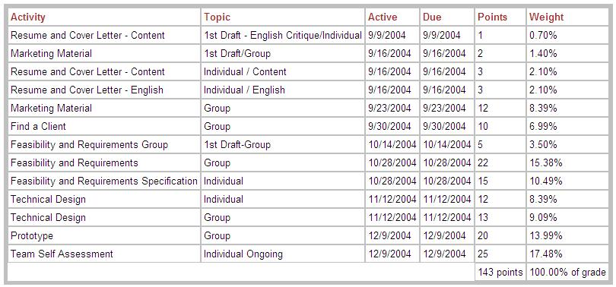
Note: For "individual" parts you get a grade for your work alone. For "group" parts everyone your team gets the same grade.

Etc.
Textbook: None. You have taken the needed courses already. Here you put it all together. Supliment what you need with any other references (management, techinical, etc.) that you need.
Lateness: Not allowed. No exceptions. Lateness as a professional is not acceptable and it is not acceptable in this class either.
Attendance: Expected. The standard KSU allowances for absence are permitted with proper documentation. Any other absence will impact on your individual contribution score.
Computer virus: It is not nice to send a virus to a server. If you do then you may render all group projects useless. So be careful!
Students with Disability: In accordance with University policy, if you have a documented disability and require accomodations to obtain equal access in this course, please contact the instructor at the beginning of the semester or when given an assignment for which accomodation is required. Students with disabilities must verify their eligibility through the Office of Student Disability Services (SDS) in the Michael Schwartz Services Center (672-2972).
Backup Your Work: Expected. Your team will be provided space on a server. The server is not backed up. It is your responsibility to maintain backup copies of everything that you develop.

